CASE STUDIES

- An electronics company produces transistors, resistors, and computer chips. Each transistor requires four units of copper, one unit of zinc, and two units of glass. Each resistor requires three, three, and one units of the three materials, respectively, and each computer chip requires two, one, and three units of these materials, respectively. Putting this information into table form, we get:
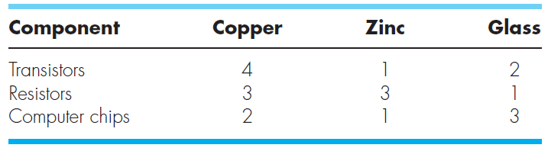
Supplies of these materials vary from week to week, so the company needs to determine a different production run each week. For example, one week the total amounts of materials available are 960 units of copper, 510 units of zinc, and 610 units of glass. Set up the system of equations modeling the production run, and use Excel, MATLAB, or Mathcad, to solve for the number of transistors, resistors, and computer chips to be manufactured this week.

- Three blocks are connected by a weightless cord and rest on an inclined plane (Fig. P12.35). Solve for acceleration a and the tensions T and R in the two cords.
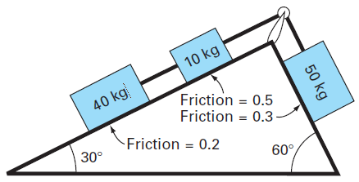
Figure P12.35

- Untuk rangkaian listrik berikut ini, turunkan sistem persamaan aljabar linear dan hitunglah arus listrik yang melalui setiap resistor dengan metode matriks.

